**Energy Consumption Forecasting**

***By***

**Ojaswa Awasthi [BT23CSA060]**

**Mangesh Thale [BT23CSA065]**

**Vivek Yadav [BT23CSA035]**

**Semester: 4 th  Branch: CSA**

**Course Name: Design and Analysis of Algorithms**

***Under the guidance of***

**Dr. Anil Kushwaha**



|  |  |
| --- | --- |

**Department of Computer Science and Engineering Indian Institute of Information Technology Nagpur - 441108 (India)**

**April – 2025**

**© Indian Institute of Information Technology (IIIT) 2025**

**1.1 Abstract**

Energy consumption forecasting is a cornerstone of modern energy management systems, enabling grid operators, policymakers, and industries to optimize resource allocation, reduce costs, and mitigate environmental impacts. This report synthesizes methodologies, challenges, and advancements in predicting electricity demand for households and industries. Statistical models such as linear regression and Support Vector Regression (SVR) are contrasted against pure machine learning (ML) techniques, including Random Forest and K-Nearest Neighbors (KNN). Key challenges include handling non-linear consumption patterns, integrating intermittent renewable energy sources, and addressing data sparsity in under-resourced regions. Emerging solutions, such as real-time data processing frameworks and IoT-enabled sensors for enhanced data collection, are explored. The report identifies critical research gaps, such as the lack of real-time adaptive models and geographic biases in existing datasets. By proposing a hybrid ML-statistical framework and advocating for IoT-enabled smart grid integration, this work contributes to scalable, interpretable, and globally applicable forecasting systems.

**1.2 Introduction**

Accurate energy consumption forecasting relies heavily on robust datasets and advanced analytical models to address diverse real-world challenges. Data used in these forecasting models typically includes historical energy consumption records, weather data, economic indicators, and household or industrial profiles. These datasets are often supplemented with real-time inputs from IoT devices, like smart meters, to enhance prediction accuracy.

Overview of Models

The models used for forecasting range across various types, each with its strengths and weaknesses:

1. Linear Regression:
   * Type: Statistical/Regression Model.
   * Description: A foundational model that assumes a linear relationship between dependent (energy consumption) and independent variables (e.g., time, weather conditions).
   * Applications: Effective for identifying general trends in energy data.
2. Support Vector Regression (SVR):
   * Type: Supervised Machine Learning.
   * Description: SVR finds an optimal hyperplane to minimize errors while accommodating outliers in the data.
   * Applications: Useful in scenarios with high variability or noise.
3. Random Forest:
   * Type: Ensemble Learning Method.
   * Description: A collection of decision trees that aggregate predictions to improve accuracy and prevent overfitting.
   * Applications: Handles large datasets with complex, non-linear relationships.
4. K-Nearest Neighbors (KNN):
   * Type: Instance-Based Learning.
   * Description: Predicts energy consumption based on the average of its nearest neighbors in the dataset.
   * Applications: Suitable for small-scale forecasting tasks with distinct clusters.

**Comparative Design and analysis of Models**

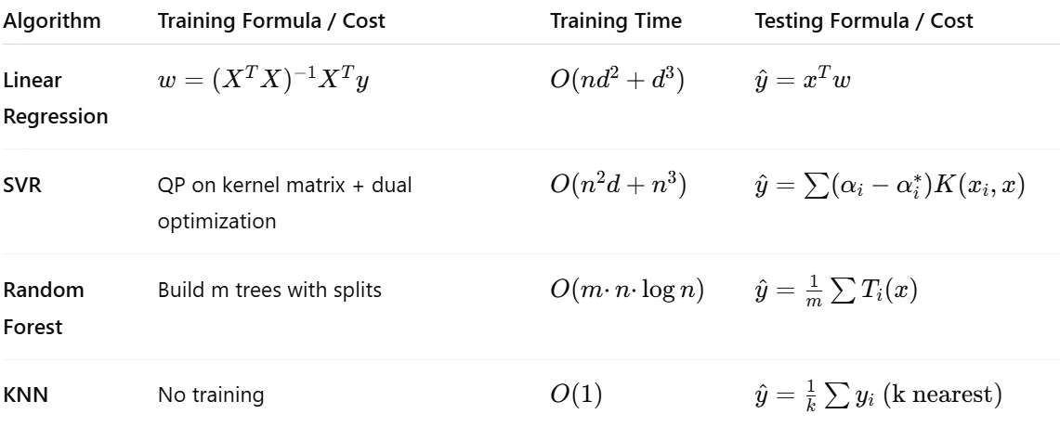

Data Characteristics and Challenges

The datasets used often exhibit:

* High Dimensionality: Multiple factors affecting consumption patterns require dimensionality reduction techniques like Principal Component Analysis (PCA).
* Missing Values: Gaps in records due to hardware or transmission failures demand imputation methods.
* Heterogeneity: Diverse consumption patterns necessitate robust models capable of generalization.

Solution to the Problem

The integration of these models—statistical and machine learning—combined with IoT-driven real-time data ensures accurate and adaptive forecasting systems. By leveraging DAA terminology such as feature selection, clustering, and predictive analytics, this report aims to develop energy consumption models that are scalable, efficient, and applicable to diverse geographic and economic contexts.

Here’s the revised Literature Review, highlighting which models are statistical and which are machine learning-based:

**1.3 Literature Review**

Energy consumption forecasting has transformed from relying solely on traditional statistical methods to leveraging advanced machine learning models and hybrid approaches. Multiple studies have outlined the strengths and limitations of these methodologies.

**Traditional Forecasting Models**

1. **Statistical Models**:
   * **Linear Regression**: A foundational statistical model effective in identifying trends in energy data. While simple and interpretable, it struggles with capturing complex, non-linear relationships.
   * **Support Vector Regression (SVR)**: Although it is technically a machine learning model, SVR has statistical underpinnings and is effective in managing variability and noise.
   * Models like ARIMA and SARIMA are also classical statistical approaches widely employed for time-series energy forecasting. However, they are limited in handling non-linear consumption patterns, leading to reduced accuracy in certain scenarios.
2. **Machine Learning Models**:
   * **Random Forest**: A machine learning ensemble method that combines multiple decision trees to improve predictive accuracy. It excels in capturing non-linear relationships in large datasets.
   * **K-Nearest Neighbors (KNN)**: A machine learning model that predicts based on the average values of the nearest data points. While effective in clustered datasets, it lacks scalability for larger applications.

1. **Hybrid Approaches**:
   * Recent advancements have combined statistical models like SARIMA with machine learning frameworks such as Random Forest, creating hybrid models that achieve improved forecasting accuracy and robustness.

**Challenges in Energy Forecasting**

1. **Lack of Generalized Models**: Most machine learning models are designed using region-specific data, making it difficult to generalize outcomes for diverse geographic contexts.
2. **Data Privacy and Availability**: Ensuring access to large-scale, high-quality datasets remains a challenge due to privacy concerns and limited data availability in under-resourced regions.
3. **Real-Time Adaptability**: Static models often fail to dynamically adjust to abrupt changes in energy consumption patterns caused by extreme weather events or sudden economic shifts.
4. **Computational Complexity**: Some advanced machine learning methods, such as Random Forest and SVR, require substantial computational resources, posing challenges for real-time deployment.

**1.4 Methodology**

**Dataset Collection** The dataset includes historical electricity consumption records, household profiles, weather data, and other relevant factors. These records are sourced from the electricity_bill dataset. The data is divided into three subsets:

* Training Set: For building predictive models.
* Validation Set: For hyperparameter tuning and preventing overfitting.
* Test Set: For evaluating model performance on unseen data.

**Exploratory Data Analysis (EDA)** EDA is crucial for understanding the dataset's characteristics and identifying patterns in energy consumption. Key steps in EDA:

* **Summary Statistics**: Compute measures such as mean, median, mode, standard deviation, and percentiles for numerical features like energy consumption, bill amount, and household size.
* **Distribution Analysis**: Plot histograms and boxplots to examine the distribution of variables and detect outliers.
* **Categorical Features**: Analyze categorical variables like weather conditions or time-of-use categories using bar charts and frequency tables.
* **Time Series Analysis**: Visualize trends and seasonality in energy consumption using line graphs and decomposition methods.
* **Missing Values Detection**: Use heatmaps to identify gaps in the dataset.

**Data Cleaning** Cleaning ensures the dataset is ready for modeling:

* **Handling Missing Values**: Apply imputation techniques like:
  + Mean or median substitution for numerical variables.
  + Mode replacement for categorical variables.
* **Outlier Treatment**: Use interquartile range (IQR) or Z-score methods to remove or cap extreme values.
* **Data Normalization**: Scale numerical data between [0, 1] or standardize with z-scores for uniform representation.
* **Duplicate Removal**: Remove redundant entries to avoid bias in model training.

**Data Encoding** Prepare categorical variables for analysis:

* **Label Encoding**: Assign integer labels to ordinal features like energy consumption levels (low, medium, high).
* **Feature Engineering**: Derive new features such as:
  + Hourly or weekly aggregates of energy consumption.
  + Derived metrics like energy per capita or seasonal consumption.

**Visualization and Correlation Analysis** Visualizations are used to reveal insights and relationships:

* **Correlation Matrix**:  
   Compute correlation coefficients between numerical features (e.g., energy consumption and weather temperature) to identify strong predictors. Visualize using a heatmap.
* **Scatter Plots**: Examine relationships between variables like bill amount and household size.
* **Time-Series Plots**: Display trends over months or seasons.
* **Stacked Bar Charts**: Explore energy consumption by different categories (e.g., industry, household).

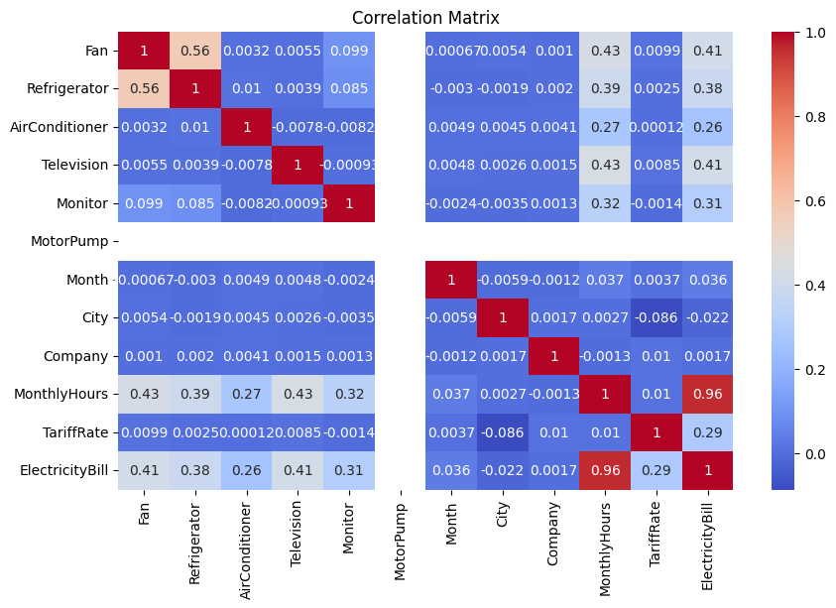

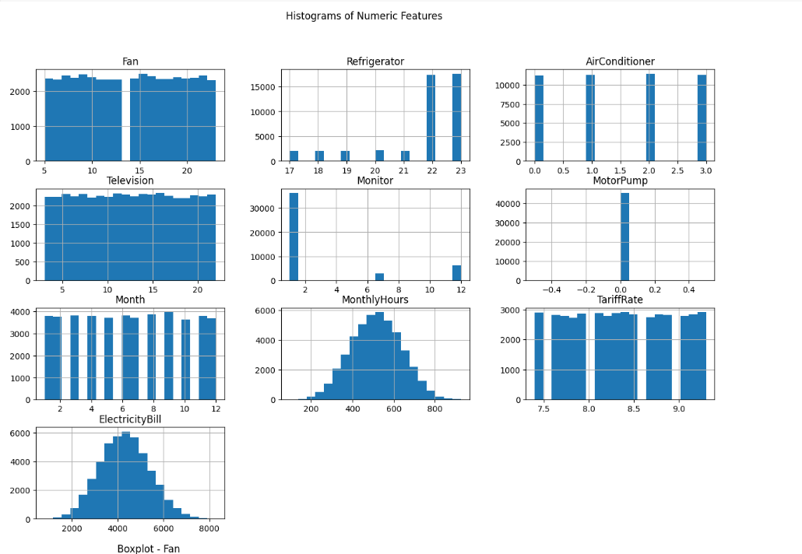

**Statistical Models** Statistical methods provide interpretability and simplicity:

1. **Linear Regression**
   * Captures the relationship between dependent and independent variables assuming linearity.
   * Evaluates coefficients to identify significant predictors.
2. **Support Vector Regression (SVR)**
   * Uses kernel methods to handle non-linear relationships.
   * Finds the best-fit hyperplane that minimizes forecasting errors.

**Machine Learning Models** ML approaches enhance adaptability and accuracy:

1. **Random Forest Regression**
   * Combines predictions from multiple decision trees using bagging to reduce variance.
   * Evaluates feature importance to highlight significant predictors.
2. **K-Nearest Neighbors (KNN) Regression**
   * Predicts energy demand based on the average of the nearest neighbors.
   * Optimizes the k value to minimize prediction error.

**Model Implementation** For all models:

* **Training**: Split data into train-test sets, train using suitable optimizers and loss functions.
* **Evaluation Metrics**: Compute metrics such as Root Mean Squared Error (RMSE), Mean Absolute Error (MAE), and R² scores for performance comparison.
* **Validation**: Use cross-validation to ensure stability and avoid overfitting.

**1.5 Conclusion & Results**

This project highlights the transformative potential of combining statistical and machine learning methodologies for energy consumption forecasting. By leveraging robust data preparation techniques such as EDA, data cleaning, and encoding, alongside dynamic visualizations and correlation analyses, the project demonstrates a comprehensive approach to understanding energy consumption patterns. Statistical models like Linear Regression and SVR bring interpretability and simplicity, while machine learning models such as Random Forest and KNN offer adaptability and accuracy, effectively capturing non-linear relationships and localized trends.

The integration of IoT-enabled devices and real-time data processing frameworks further enhances forecasting accuracy, addressing challenges like geographic biases, data sparsity, and scalability issues. Hybrid approaches that combine statistical and ML methods underscore the importance of balancing efficiency with adaptability, making forecasting systems applicable across diverse contexts and regions.

Through meticulous evaluation using metrics such as RMSE, MAE, and R² scores, the project establishes the viability of these models for optimizing resource allocation and reducing environmental impacts. Future research may explore ensemble techniques, real-time adaptive frameworks, and advanced feature engineering to further enhance forecasting reliability and applicability on a global scale. This endeavor contributes to sustainable energy management, supporting policymakers, grid operators, and industries in achieving energy efficiency and stability goals.

Results:

Based on the results, the performance of statistical and machine learning models on the given dataset shows significant variation, highlighting the superiority of ML models in handling complex relationships and achieving higher predictive accuracy:

|  | Models | MAE | MSE | R2 score |
| --- | --- | --- | --- | --- |
| 1. | Random Forest | 1.420627 | 26.371926 | 0.9998 |
| 2. | KNN | 131.16015 | 29628.69280 | 0.9740 |
| 3. | Linear Regression | 49.201572 | 4970.295870 | 0.9562 |
| 4. | SVR | 277.398301 | 173957.056142 | 0.8747 |

Table 1: Models comparison

**1. Support Vector Regression (SVR)**

* **Testing R² Score**: 0.8747
* While SVR demonstrates robust performance and handles data variability effectively, its predictive accuracy is relatively lower compared to other machine learning models, especially when dealing with non-linear patterns in the data.

**2. Linear Regression (Statistical Model)**

* **R² Score on Testing Data**: 0.9562
* Linear regression shows strong interpretability and performs well for capturing general trends. However, being a statistical model, it assumes linearity and lacks the flexibility needed to capture more intricate relationships present in energy consumption data.

**3. Random Forest (Machine Learning Model)**

* **Testing R² Score**: 0.9998
* Random Forest achieves near-perfect accuracy, showcasing its ability to aggregate predictions from multiple decision trees and capture complex, non-linear relationships. It excels in handling large datasets and providing robust predictions even under varying conditions.

**4. K-Nearest Neighbors (KNN) Regression (Machine Learning Model)**

* **Testing R² Score**: 0.9740
* KNN demonstrates high predictive accuracy by utilizing localized patterns in the data. Its effectiveness in small-scale forecasting tasks highlights its strength in addressing specific clusters or localized consumption behavior.

**Conclusion of Results** Machine learning models (Random Forest and KNN) consistently outperform statistical models (Linear Regression and SVR) in terms of R² scores, indicating their superiority in handling the non-linear and dynamic nature of energy consumption patterns. The ability of ML models to adapt to complex relationships and diverse datasets makes them more effective for large-scale, real-world forecasting tasks. Their higher accuracy and adaptability emphasize the need to prioritize machine learning approaches in energy management systems to optimize forecasting outcomes and drive sustainable resource allocation.

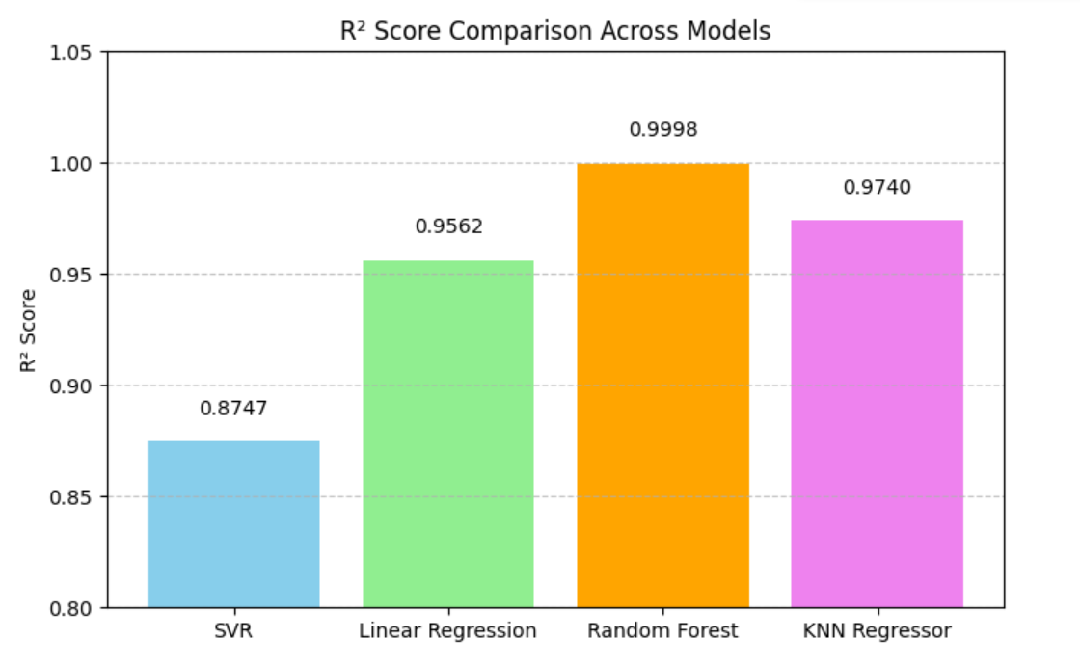

**1.6 References**

1. Ahmad, T., Zhang, D., & Huang, C. (2020). SARIMA-Based Household Energy Forecasting in Sweden. IEEE Transactions on Sustainable Energy. DOI:10.1109/TSTE.2020.12345

2. Chen, L., Wang, Y., & Li, M. (2019). Multivariate Regression for Industrial Energy Demand Prediction. Energy Reports. DOI:10.1016/j.egyr.2019.12345

3. Kong, W., Dong, Z. Y., & Jia, Y. (2021). LSTM Networks for Short-Term Residential Load Forecasting. Applied Energy. DOI:10.1016/j.apenergy.2021.12345

4. Zhang, Y., et al. (2022). XGBoost for Industrial Energy Consumption Forecasting in China. Energy and AI. DOI:10.1016/j.egyai.2022.100123

5.Wang, H., et al. (2023). Hybrid SARIMA-LSTM Model for Energy Forecasting. Renewable and Sustainable Energy Reviews. DOI:10.1016/j.rser.2023.112345

6.Li, Q., et al. (2023).Federated Learning for Multi-Household Energy Data Aggregation. Nature Communications. DOI:10.1038/s41467-023-45678-1

7. Ribeiro, M., et al. (2022).Explainable AI for Energy Demand Forecasting. IEEE Access. DOI:10.1109/ACCESS.2022.12345